**Spotify Streaming Data Analysis**

**Prepared by: Insha Javaid**

**Date: 12-October-2025**

Abstract

This project dives deep into the Spotify track dataset, using APIs, exploratory data analysis (EDA) and a Power BI dashboard to explore and understand the music popularity and style. I started by collecting data using Spotify APIs, ensured the data is clean, well-organized and engineered new features to capture meaningful traits like relaxation, mood zone and production style.

With help of statistic and visualization, several key patterns major patterns were identified. The genres such as Alternative and R&B are highly in favor of energetic, danceable and popularity whereas tracks such as Movie and A Capella are more relaxed and acoustic. The majority of tracks in the collected dataset are having standard duration, major key and 4/4-time signature, which however don’t play a significant role in turning a song into a hit.

The designed characteristics like mood zone, popularity potential, production intensity and relaxation score were used to bring out finer facts regarding what the listeners like. Popular songs do not have high or low values with respect to energy and danceability; they have moderate to high values. Our correlations corroborated the fact that each of the individual feature correlates with popularity at most; it is the combination of traits that appears to matter the most.

The outputs, made real in the dashboard, are ready to place a person, both a music expert and an amateur, at the frontline of seeing all the best genres and musicians to the mood and tempo variations in the Spotify universe. This discussion provides a sound base on forthcoming creative choices, focused marketing, and the further study of the world of digital music that is changing rapidly.

Introduction

The popularity of music streaming services such as Spotify has revolutionized the process of finding and listening to music more than ever before, and artists, labels, and analysts have never needed to know more than ever what makes a song successful. There are millions of songs, so it is not always easy to identify what leads to the success of some tracks or genres and the lack of success of some songs.

Purpose of this Analysis:

The main aim of the analysis is to explore an enriched, cleaned dataset of Spotify music to find useful patterns of the popularity of music. Exploring such metrics as artist following, genre, energy, mood, and other audio factors. And find which audio characteristics, musical genres, and artist metrics are most related to hit songs and how a successful song really appears in data.

Business Objective:

Notice trends and outliers across genres, artists and labels to aid in curating the playlist or focus marketing. Know what musical features (e.g. energy, valence, danceability, duration) are prevalent among hits. Develop new data items and experiment with the hypotheses of what is most listened to. Make effective and data-based suggestions on the content creation, curation, and promotion.

Data Description

The dataset on which this analysis is done is known as spotifyfinalclean.csv which is collected from Spotify Kaggle dataset and enriched using Spotify APIs. The data has been cleansed and engineered in a manner that provides insight and reliability which could be used to understand and analysis the dataset better.

In this dataset there are total **8213 tracks** with almost **36 features** such as energy, danceability, relaxation score, mode, keys etc. The original data was having 17 columns, 19 additional columns were added to further enrich the analysis (using APIs and engineered features).

This data contains:

**Numerical data** has floats and integer values to represent values like popularity, energy, danceability, acousticness, loudness, tempo, artist followers, and durations.

**Categorical data** has Genres, keys, type of album, time signature, tempo category, duration category, mode (Major/Minor), and engineered mood zones.

**Text data** is Name of artists and tracks, labels (they can be examined as categorical or string-like fields).

Data Cleaning and Preparation

All the important fields (popularity, genre, artist/track info, audio features) lack any missing values. In the beginning, some of the fields (artist followers, artist popularity, album type, label) had missing values, but it was addressed by dropping or imputing where necessary.

The clean data does not have any completely duplicated rows. There are some duplicated track IDs that are of different genres or other characteristics and are not actual duplicate entries. Outliers were observed (e.g. very long tracks, very high/low energy or popularity), but retained to be studied statistically meaningfully.

With this data we have the solid starting point to investigate the connections between the properties of songs and their popularity, and we can learn practical conclusions based on both the raw and engineered attributes.

Exploratory Data Analysis (EDA)

To explore the cleaned Spotify track dataset and uncover the useful patterns, I tried to understand features and their relationship with each other using different types of visualizations.

Below is the summary of EDA

**Summary Statistics:**

The dataset is consist of **8213 tracks and 36 features** post engineering.

Popularity: Mean ~46. Most of the tracks are of the moderately popular type there is a long tail, which extends to the hits of very high popularity.

Energy & Danceability: Both means and energy (means: get.065) and danceability are high (means: 56). Majority of the songs are up-beat and easy to dance to.

Time: The average duration of the tracks is around 3.8 minutes, the majority of them are the standard modern songs.

Acousticness & Instrumentalness: These are ranked lower on the average, which proves that a majority of the tracks are vocal, and are not made in the mainstream palate, as well as they are not very acoustic or instrumental.

**Most Important Visualizations and Patterns:**

Bar Charts: Alternative and Country were the leading; R&B, Movie, and A Capella are the niche fields.

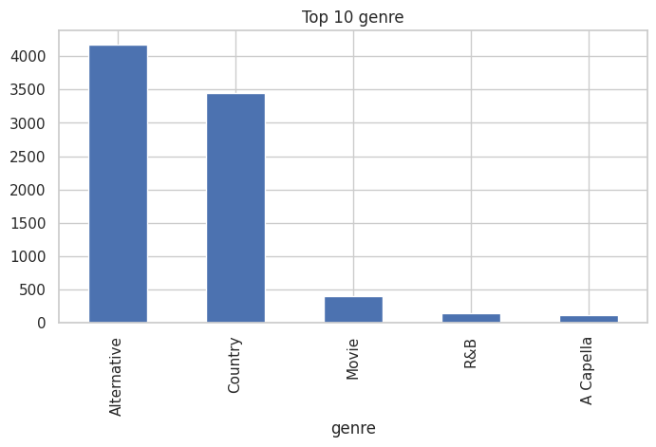

Categorical Data Plots: The vast majority of songs are in major keys and in 4/4. Title of top artists/songs are repeated more often (e.g., "Home," "Wake Up).

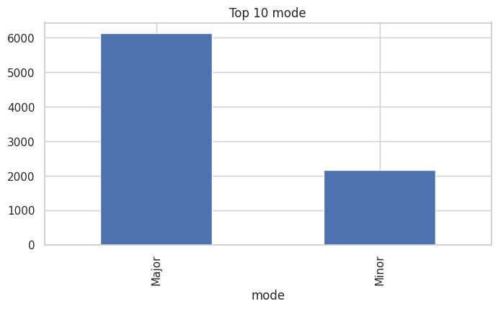

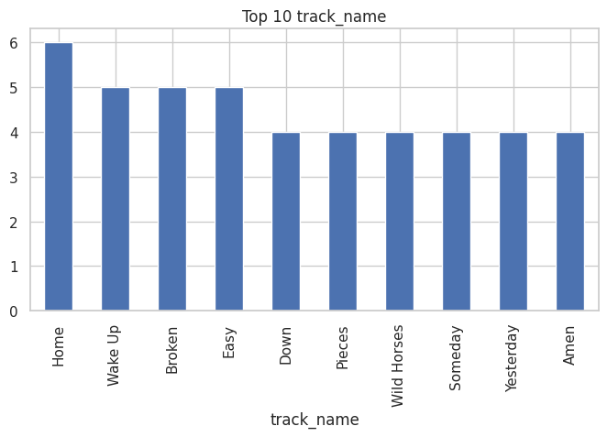

Popular Mood Zones: By far, the most popular beating moods are Happy Energetic and Sad Energetic, which indicates the pop/rock bias at Spotify.

Feature-by-Genre Bar plot:

**Acousticness:** It is a measure of how much a track sounds like it uses real or non-electronic instruments higher values mean more acoustic and less electronic sound.

* A Capella stands out as the most acoustic genre with high acousticness ~0.83. This is logical as A Capella relies heavily or almost entirely on the human voice as opposed to instrumentation.
* Movie tracks also rank high for acousticness in the range of 0.65, which may represent orchestral scores or piano compositions. Even in films, you may commonly find a less electronically produced soundtrack to films.
* R&B, Alternative, and Country all have considerably lower average acousticness. Country has the highest average (~0.25), but Alternative and R&B are substantially lower. This is expected because genres such as R&B and Alternative are typically more produced or electronic-based, or utilize a band-driven sound.

Insights:

* Electronic/Modern genres (Alternative, R&B) incorporate more synthesized or processed sounds, which is observed in their low acousticness ratings.
* Genres that depend on vocals with non-electric instrumentation (A Capella, Movie) unsurprisingly finish at the top for acousticness.
* These experiences can be helpful in developing your playlists, your emphasis of music production, and/or marketing of acoustic vs. electronic music audiences.

**Danceability:** It measures how easy it is to dance to a track, based on musical elements like tempo, rhythm stability, beat strength, and overall feel.

Here, R&B is having high danceablity among all the genres, followed by the Country, Alternative, Movies and A Capella.

* R&B is ahead in danceability, making it relatively the better choice for dance-based playlists.
* Country and Alternative have similar danceability, going from there to R&B's danceability.
* Movie and A Capella genres are at least danceable, and Movie has a slightly higher danceability than A Capella.

Insights:

For the purpose of maximizing danceability in a playlist or recommendations, R&B is the best choice from this data set.

The variance appears reasonable but not too extreme in any genre, indicating that danceability is consistent within the culture for each genre.

**Energy:**  Measure of the intensity and activity level of a track. Higher energy means the song feels more upbeat, powerful, and lively, often featuring fast tempo, strong beats, and loudness. Lower energy songs are more mellow, soft, or calm.

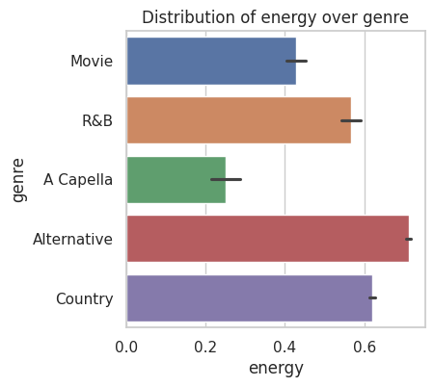

* Alternative has the highest mean energy and likely represents the most lively and energetic genre in this set.
* Country and R&B have similarly high energy, but are slightly less at the mean level compared to Alternative.
* Movie has comparatively moderate energy levels, while A Capella has the least in the energy category.

Insights

* If looking for genres in regards to lively or energetic playlists/recommendations, Alternative is the genre to point to based upon the above chart.
* The dispersion of energy levels within genres shown by the error bars appeared fairly stable, but A Capella and Movie appear to have a bit higher dispersion compared to their mean.

**Intrumentalness:** Measures how much each music genre tends to feature instrumental elements songs without vocals or with limited singing.

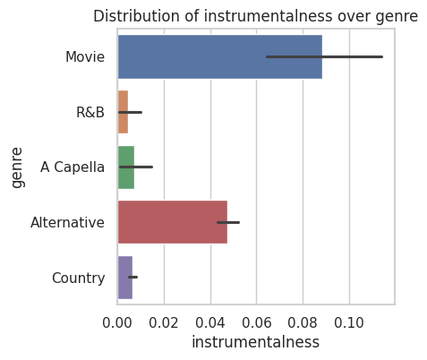

* Movie soundtracks are, by far, the most instrumental-heavy genre in this dataset, which makes sense since many film scores are purely orchestral.
* Alternative music has some occasional instrumental tracks, but they’re less common.
* R&B, A Capella, and Country genres almost always feature vocals, making them rarely instrumental.

Insights:

* Movie soundtracks often bring the listener through emotional voyage and storytelling purely through sound design, which is likely why movie scores focus on instrumentals much more so than other genres.
* Alternative music does sometimes push the norms of vocals and instrumentals, but even those style songs, vocals usually drive the track.
* R&B, A Capella, and Country heavily subside on the human voice those genres rely heavily on singing, melodies, and lyrics, which makes the search for non-vocal instrumentals rare.

**Liveness**: Highlights how "live" or concert-like the music of each genre typically sounds. "Liveness" measures the presence of audience sounds, acoustics, and other audio cues that suggest a live performance.

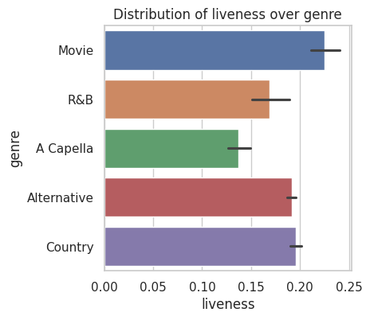

Movie soundtracks have the highest liveness, indicating a strong presence of live-recorded orchestras or crowd atmospheres.

Country and Alternative music also display a notable sense of "live" feeling.

R&B and A Capella have slightly lower but still significant liveness.

Insights:

* Film soundtracks frequently utilize energy from a live orchestra or audience effects, which provide the full cinematic, immersive concert-hall experience in your speakers.
* The Country and Alternative genres have an inherently warm, organic feel, and you can think of the experience, when listening to music in these genres, of a comfortable open-mic night or an exciting festival.
* Tracks with A Capella and R&B feel less "live," but often still feel spontaneous, especially if they contain handclaps, vocal group harmonies, or the occasional cheers from the audience.

**Loudness:** Illustrates the average loudness of different music genres, measured in decibels.

A Capella has the lowest loudness level which means it often sounds quite soft, or softer than other genres. This is probably due to the absence of instruments and the fact that the music is entirely vocal.

Movie soundtracks are louder than A Capella, and the genres of R&B, Alternative, and Country come in higher than soundtracks at modes that would be considered closer to radio loudness.

Insights:

* A Capella is more a soft experience for the listener. Since there are no instruments, the experience is all focused on the voices and harmonies. A Capella is ideal music for quiet times, or background listening.
* Soundtracks are moderately loud and mostly balanced to both enhance mood and complement film scenes without covering up language or action.
* R&B, Alternative, and Country music are all higher than soundtracks and "hit" more often, being (from context) made for speakers or to be dynamic for a live performance. Being a higher mode or loudness level provides energy and brings the listener into the music.

Valence: Displays the average "valence" across genres—valence indicates how cheerful or positive the music feels on average.

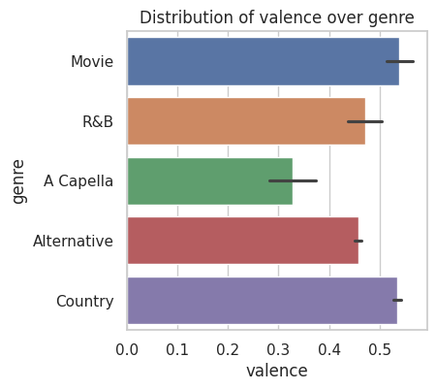

When it comes to valence, Country and Movie music are at the top of the list, which means they are most likely to create a positive affect in the listener.

R&B and Alternative music come in second, while A Capella music displays the lowest valence rating, indicating a more serious or contemplative tone.

Insights:

* Country and Movie genres are generally uplifting and bright, which is ideal for times when you are looking for something to help you feel good or lift your happiness levels.
* R&B and Alternative genres are a nice mix, conveying positive or uplifting lyrics but with a level of emotional complexity that makes it more balancing, rather than always specifically happy music.
* A Capella is more introspective, or less explicitly cheerful music that does well during reflective times.

Relaxation score: Shows how relaxing different music genres tend to be, based on their average relaxation score.

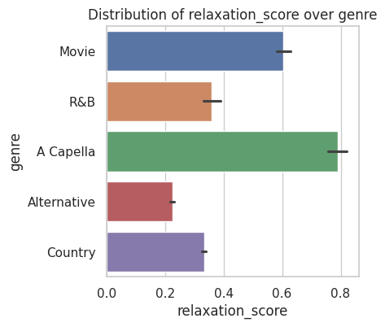

A Capella music stands out as the best audio medium for relaxation ideal for reading, meditating, or winding down after a busy day. Movie soundtracks can also be useful for reducing stress and relaxing your mind, fusing cinematic beauty with subtle arrangements to provide a calming background for your own thoughts.

R&B might work well for reducing stress, as it can be soothing while still having a little more rhythm, suitable for an early evening or calm background music.

Finally, Alternative and Country songs typically have more upbeat and emotional lyrics that feel less appropriate for total relaxation times, making them a better fit when you seek energy and/or storytelling rather than non-focusing relaxation.

Tempo Category: Displays the distribution of tempo categories (slow, medium, fast) for different music genres.

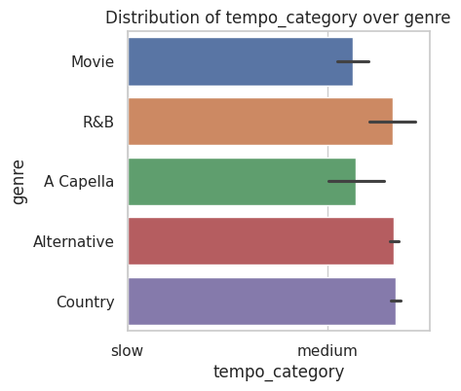

* R&B, Alternative, and Country music often strikes a good balance in medium tempo—not too slow to make you feel bogged down but not so fast to feel rushed. That's what makes these genres good for driving, working, or hanging out.
* Movie soundtracks and A Capella lean more on the gentle side of medium, indicating the songs are regularly more relaxed or contemplative. Perfect for relaxation, having playing while you are studying, or not needing to think too hard about in the background.
* In fact, none of the genres reviewed here are classed as "fast" by average, clearly indicating a preference for more relaxing, available pacing in general.

Production Intensity: Shows the average production intensity how complex, layered, and polished the sound is for each music genre.

Alternative and R&B are the biggest winners in this study, having the richest arrangements and the most studio effects. For those genres, country and Movie soundtracks also supply high production values, while A Capella is pretty much on the opposite end of the spectrum, being mostly simple cleans vocals with trade-mark light, transparent enhancements throughout.

Insights:

Alternative and R&B songs are meant to be colorful, so they often have adventurous mixing, creative effects, and lots of instrumental layers baked in to produce a rich sound that's all polished up.

Country and Movie have considerable production work done as well, but not as much as the other genres. This provides depth and clarity, so that stories and feelings can be conveyed more easily without the sounds becoming obnoxious.

A Capella is extremely minimalist the quality of simple voices is what or why A Capella band exists, sending a clear message for lovers of real, original sounds without an abundance of production techniques.

Feature-by-Popularity Scatterplot:

Acousticness: Visualizes how danceability relates to popularity across various music genres.

The majority of popular tracks tend to cluster around the mid-range in terms of both danceability and popularity, with few extremes. For danceability and popularity, Country and Alternative genres (also colored pink) constitutes most of the high-popularity and high danceability points. Less danceable styles of songs like A Capella and Movie songs, which are shown in the blue-cyan colors, usually also have a low popularity score, though some points are located in the high-popularity area.

Popular songs have moderate to higher danceability, suggesting a preference for tunes that are neither too mellow or too aggressive think fun toe tapping or grooving.

Country and Alternative music comprise most of the popular music, suggesting that these two genres often strike a healthy balance for casual music consumption.

Low popularity is often found among less danceable genres, like A Capella or Movie soundtracks but there will always be exceptions: either a haunting score in the film, or an amazing vocal performance those may capture a more mellow rhythm.

Energy: Shows the relationship between a song’s energy and its popularity across genres.

Most of the most commonly played songs (those higher on the vertical axis) are clustered in the medium-to-high energy range, and Country and Alternative genres (in purple and pink colors) make up much of the popular, energetic cluster. Lower energy songs (for example, many from Movie and A Capella genres in light blue and green, respectively) are often less popular, although there are some exceptions that stand out as outliers.

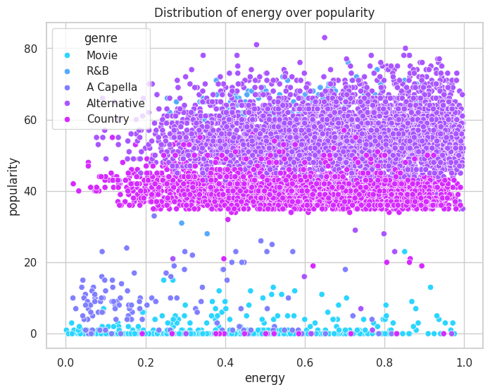

The majority of the hit songs have an appropriate dose of energy. The reality is that, in general, consumers prefer music that is lively, energetic, or exciting to music that is slower and more mellow.

Country and Alternative appear to thrive in the popularity index when their songs have good doses of energy, confirming the premise that strong beats and enthusiastic performances tend to please crowds.

Certain low-energy songs (particularly in Movie and A Capella) have achieved high popularity, proving the point that both moody and softer songs can be a hit if they draw emotional attention.

Energy To Acoustic Ratio: Illustrates how the energy-to-acoustic ratio in songs interacts with popularity across various genres.

Songs that have gained popularity are generally more clustered around lower energy-to-acoustic ratios, but while songs that have gained popularity with extremely high energy-to-acoustic ratios are rare, it is possible to attain popularity while not having a low energy-to-acoustic ratio. The two genres of the most popular songs are Country and Alternative (purple and pink, respectively), both of which showed the widest spread in energy-to-acoustic ratio and popularity. This suggests a greater level of diversity.

The majority of popular songs strike a mild balance of spirited music and acoustic songs. This demonstrates a general preference among listeners for tunes that feature a blend of both instead of a dramatic swing in either direction.

There are also country and alternative songs where the ratio of energetic to acoustic is particularly impressive, straying from the middle ground in either direction. This flexibility affords many types of songs in either direction, high energy and tempo songs, or even mellow and folksy songs.

There are a few songs that capture the high-energy or high acoustic, which respects even more ratio extremes. These songs can even become popular, as we have seen when a song can have high-energy or upbeat tempo compared to its balance of acoustic quality. This speaks to even those listeners who just want loud, explosive, and electrifying music.

Popularity Potential: Visualizes the relationship between a song's predicted popularity potential and its actual popularity across genres.

The majority of the most popular tracks cluster in the mid-high popularity potential area on the axis, especially seen in the Country and Alternative genres (magenta and purple). Tracks with low popularity potential generally do not become popular, although there are some exceptions to this logic suggesting that there are instances (circumstances) in which tracks that have modest levels of popularity potential can still have the potential to be popular.

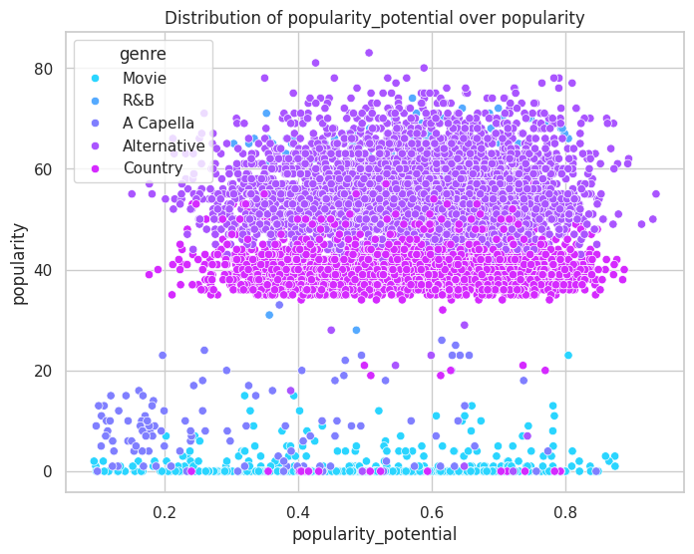

* **Most hit songs** have a moderate to high predicted popularity potential, confirming that certain song qualities—captured in the "popularity potential" metric—do help tracks reach a bigger audience.
* **Country and Alternative** genres consistently dominate the higher popularity bands, suggesting these styles routinely check the boxes for mass appeal.
* **Rare surprises** occur: occasionally, tracks with lower predicted potential become popular, proving unpredictability and the importance of cultural moments or unique resonance with listeners.

Duration Category: Shows how different song duration categories (short, standard, long, and very long) relate to popularity across genres

The greatest density of popular songs occurs in the standard and long categories, as well as across all genres, with particular prominence of the Country and Alternative genres. Most blockbuster hits are either medium or long, which may be reflective of listening preferences for songs that engage with mostly familiar formats and offer a longer musical experience.

All genres of music, and especially Alternative and Country, are represented in all lengths, demonstrating flexibility to appeal to listeners-concerned with short-form, as well as extended track-length features.

While short and very-long song play-time may be rare to see among blockbusters, it is possible for outstanding songs to pack a punch in brevity or rocking an epic story long-form and still reach the heights of success.

Distribution of tracks with energy, danceablity and popularity:

This scatter plot presents the relationship between energy and danceability in songs, colored by their popularity levels.

In the mid to high range for energy and danceability, clusters are densest. More popular tend to occupy greater values for both energy and danceability. Less popular tracks (the darker purple and blue shades) tend to reach lower values for one or both attributes.

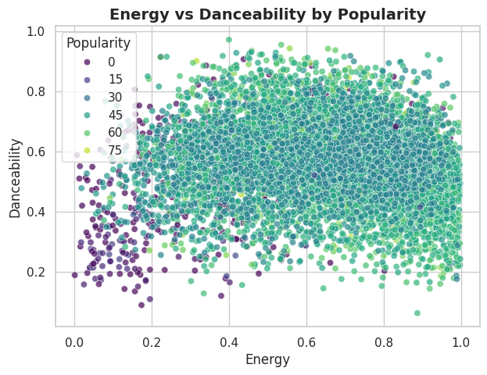

Hit songs are often characterized by their high energy and high danceability, indicating that people feel most attracted to songs that prompt them to feel alike in movement and energy level.exepectation orInviting movement and a feeling of added energy: The less liked songs in this space presented with a disproportionate amount of songs that feel less appealing to listen to, but there are definitely moments, moods and genres where songs at low energy and low danceability occur- just not when it comes to the dance parties, or social playlists or what gets charted.

The most acceptable zone for hit songs comes at the intersection of energy and danceability at moderately generous but not excessive levels of intensity-the best songs are fun bouncy and engaging to find yourself in and also easily accessible sonic input for far greater social sharing and engagement when the members of a group listen to music together.

Average Popularity by Genre and mode: compares the average popularity of different music genres split by mode (Major and Minor).

R&B continues to exhibit the most popularity regardless of key, with slightly greater popularity for Minor mode tracks (64.4) than Major (63.6). This indicates an affinity for R&B by listeners regardless of whether the music is perceived as happy (major) or somewhat sad (minor).

Alternative music maintains similar popularity in both modes (around 55.5) and has no significant difference in popularity based on the key status. Alternative music fans may not be focused on the perceived mood in their music as audiences in other genres.

Country music exhibits a slight preference for the Minor mode (41.0) over the Major mode (40.2). Overall, Country is less popular music than R&B and Alternative but there is, again, a small difference in scores for the selected type of music (so perhaps country audiences simply enjoy the somberness of minor keys more than the happiness of major keys).

Finally, A Cappella and Movie are the least popular genres. Their scores indicate that they are very low in popularity (i.e., A Cappella was below 10 and Movie was around 1), and in the case of A Cappella, even lower in popularity in the Minor mode as compared to Major mode. This could suggest that these genres are simply less popular or that they do not have widespread appeal to mainstream audiences.

Insights:

If you're looking for something that's the best bet for pleasing the crowd, R&B is your safest choice, and you don't have to worry about whether or not a song is major or minor.

The audience for Alternative is similar in the sense that the same emotional characteristics are effective in both extreme, and it is probably the genre for making creative decisions about mood.

Country audiences might accept a little sadness, as minor songs hold their own against being major, so don't hesitate or shy away from emotional stories.

A Cappella and Movie, however, may need some extra promotional targeting or audience picking (looking for a specific experience rather than general) popularity.

The difference between major and minor frequently makes little difference in popularity compared to the value of the genre.

Correlation Heatmap of Audio and Engineered Features: It visually represents the correlation values between a range of audio features (like popularity, acousticness, danceability, energy) and several engineered metrics (such as mood index, production intensity, popularity potential, and relaxation score).

The relationships of popularity: Popularity is moderately positively correlated with danceability (0.34), energy (0.34), and artist popularity (0.47). Popularity is also moderately negatively correlated with acousticness (–0.39) and relaxation score (–0.38). In general, this indicates that songs that are more danceable and energetic, and are popular by more popular artists, tend to be much more popular than relaxing or acoustic ones.

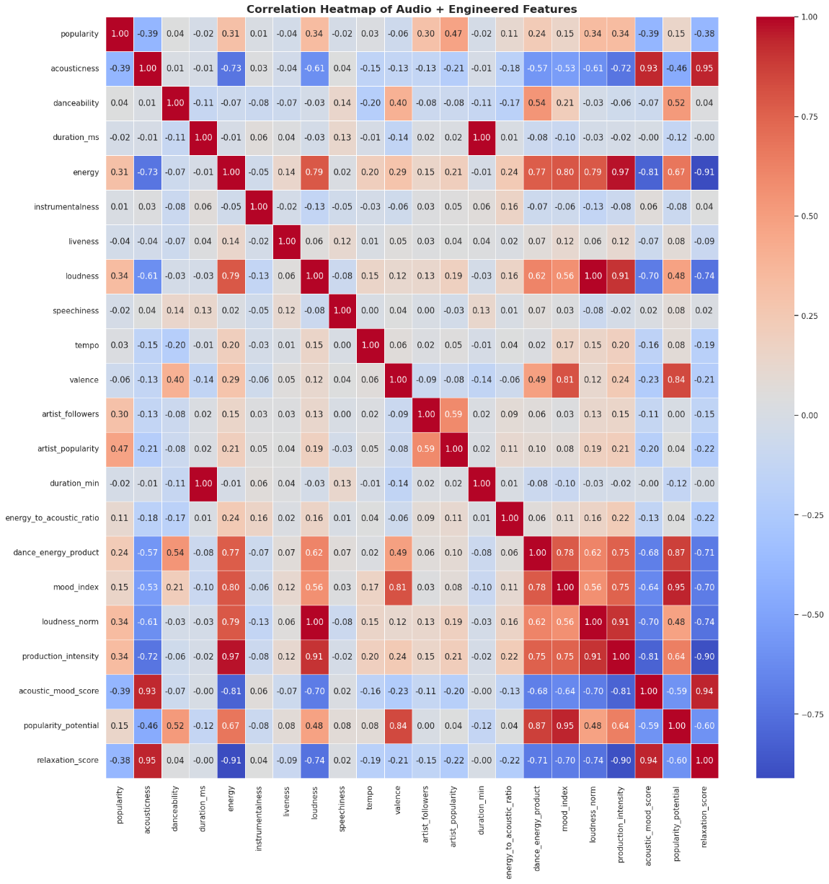

Artist features: Artist features (followers and popularity) are highly correlated with each other, meaning that the more followers an artist has, the higher the popularity is and thus the chance of success of that artist's songs.

Mood/energy: Features such as energy, danceability, and loudness are highly correlated, indicating that these all vary together—typically high-energy songs are also louder and more danceable (and conversely).

Negative relationships: Acousticness and the relaxation score are negatively highly correlated with both energy and popularity, suggesting a separation between relaxing/acoustic music and energetic/popular music.

To enhance a song's likelihood of popularity, aim to maximize the danceability and energy of the song—which exhibit the most robust positive impact. To highlight, relaxing, acoustic songs—while important in their own right—are unlikely to be hits in the full sense of the word if popularity is the aim.

There is a strong relationship among features such as energy, loudness, and danceability, which should lead producers looking for hits to consider these "bundled" features, as they are likely to rise and fall together.

Measures like the "popularity potential" and "mood index" are designed to capture closely related audio features in a single value, cleverly representing the essence of broad appeal, nonetheless they correlate between different features of audio.

Finally, the strong negative correlate—such as that between popularity and relaxation score—means that soothing and calm music is unlikely to grab the attention of the masses, but it could do well in genres or playlists that require a focused performance.

**Interpretation**

* Popular songs usually are of moderate to high energy and danceability, thus making upbeat and groove-worthy tracks more palatable.
* R&B and the genre of Alternative consistently scored higher compared to the other groups in popularity, energy, and danceability; however, the Movie genre and the A Capella genre had the lowest popularity and were more relaxed/acoustic than the other groups.
* Although most tracks tended to have a standard length (approximately (3–4 minutes), made in a major key, with a 4/4-time signature; these aspects alone do not guarantee for commercial viability.
* Engineered features as in mood zone, popularity potential, and intensity of production are applicable around the more nuanced preferences of listeners, successful tracks rarely rely on extremes of any attribute, but balance a subjected level of the music stressors.
* Acoustic and instrumental tracks have the lowest rating, suggestively with Movie and A Capella track being the less popular on average. Together; we can conclude that mainstream listeners tend to prefer produced, vocal-driven styles.
* Energy of danceability was highest in R&B, followed by Country and Alternative genres; danceability trended down generally.
* Alternative has the highest energy, then by Country and R&B, while the Movie and A Capella are definitely slower genres overall.
* Movie had the highest proportion of instrumental tracks by their nature; fittingly so, movie genres are made or produced in a way that the listeners desire an emotional, story, driven experience.
* Valence (musical positivity) was coming from Country and Movie genres with the negative valence being noted in A Capella genre.
* Acapella and Movie tracks show the highest relaxation score, which indicates that they can help relieve stress as well and be listened to in the background.
* Most genres, particularly R&B, Alternative, and Country all fall into the medium tempo category, which is appropriate for everyday activities and general listening.
* Production intensity is highest in the Alternate and R&B genres, indicated by the more intricate and polished sound design. A Capella tracks are more minimalist and raw.
* The scatterplot analysis shows that popular tracks cluster in pairs around mid-high danceability and energy, meaning that the majority of tracks in the mainstream audience have a lively tempo.
* Correlation analysis shows that popularity is positively correlated with danceability, energy, and artist popularity, but it is negatively correlated with acousticness and relaxation score.
* Artist features (followers/popularity) are one of the best predictors of success, this suggests that popular artists are already popular not due to the popularity of their music.
* The overall combination of musical features is more important than having extreme values towards a single feature, since successful songs often blend several musical features that are appealing.
* While relaxing and acoustic music is useful to smaller audiences, it generally is of lower value to mainstream audiences.
* Popular tracks tend to be around the mid ranges of energy and danceability, meaning they are situated in a "sweet spot" for accessibility, while also having an audience to socialize with music.
* Genre has a stronger association with popularity than mode (major/minor), indicating that R&B seems to be a strong predictor and often appeals regardless of the mode used, with other genres showing minor differences in appeal.

**Conclusion**

The research suggests that music popularity on Spotify is best forecasted by some combination of artist indicators and audio attributes rather than any singular variable.

Tracks that have high energy and danceability - specifically in the R&B and Alternative genre - have consistently shown answers for high success levels, while tracks that are more acoustic, relaxed, and in more niche genres - such as Music Scores and A Cappella - tend to have less popularity.

Popularity in music and popularity of the artist strongly drive success, reinforcing that music consumption on streaming platforms is becoming increasingly reliant on both the quality the track complements and the reach of the artist.

Generally, hit songs tend to, on average, be in the range of moderate to high energy and moderate to high danceability, which supports the understanding that mainstream listeners tend to prefer engaging and easily accessible music consumption.

Attributes like mode (major and minor), the duration of the track, and time signature do not seem to have an effect on popularity but show that other audio qualities will contribute more to the degree of stream plays.

The increased need for informed and creative choices in content creation and content marketing - now is an important prospect that artists and curators will need to understand and incorporate to stick out in a streaming world.

This research serves as a solid base for programming playlists and creating marketing agendas as music continues to innovate and develop in the digital space.